# Exploring Coursera

How many features we want to use and which features do we think are important?

How do we use features that are text, but maybe important?

Run algorithms with multiple features to test?

# Trying the data with one feature like LotArea

When using LotArea, I would expect, the more square feet the higher the sales price. But this isn’t the case; it of course depends on more features then only square feet.

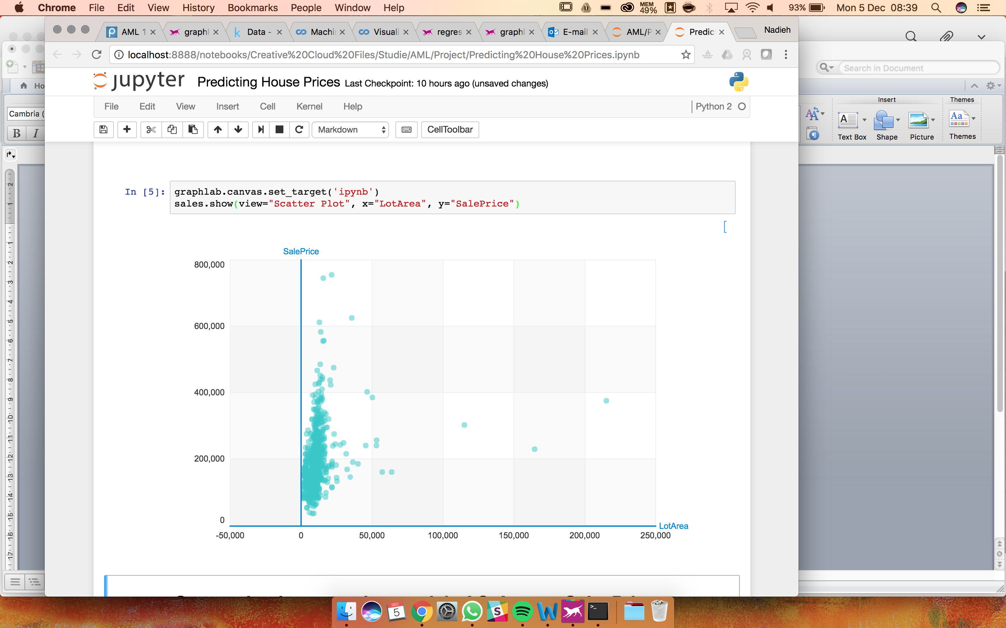

## Predict model LotArea

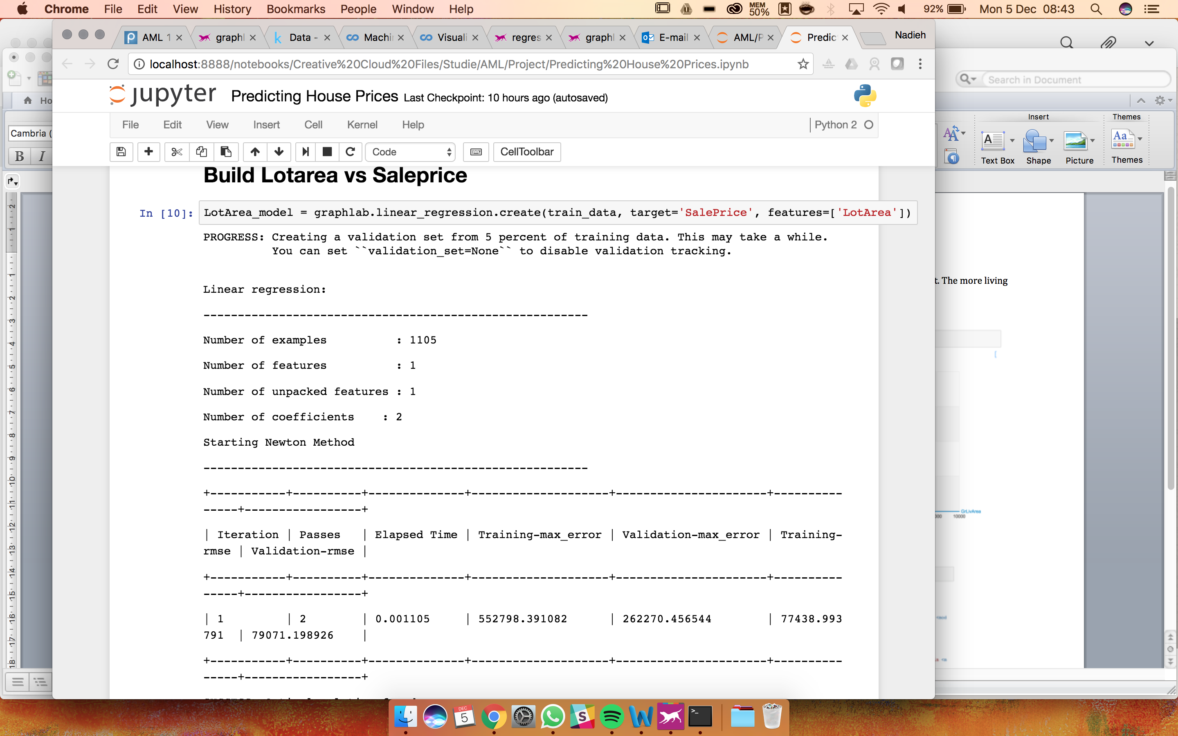

## Evaluate model

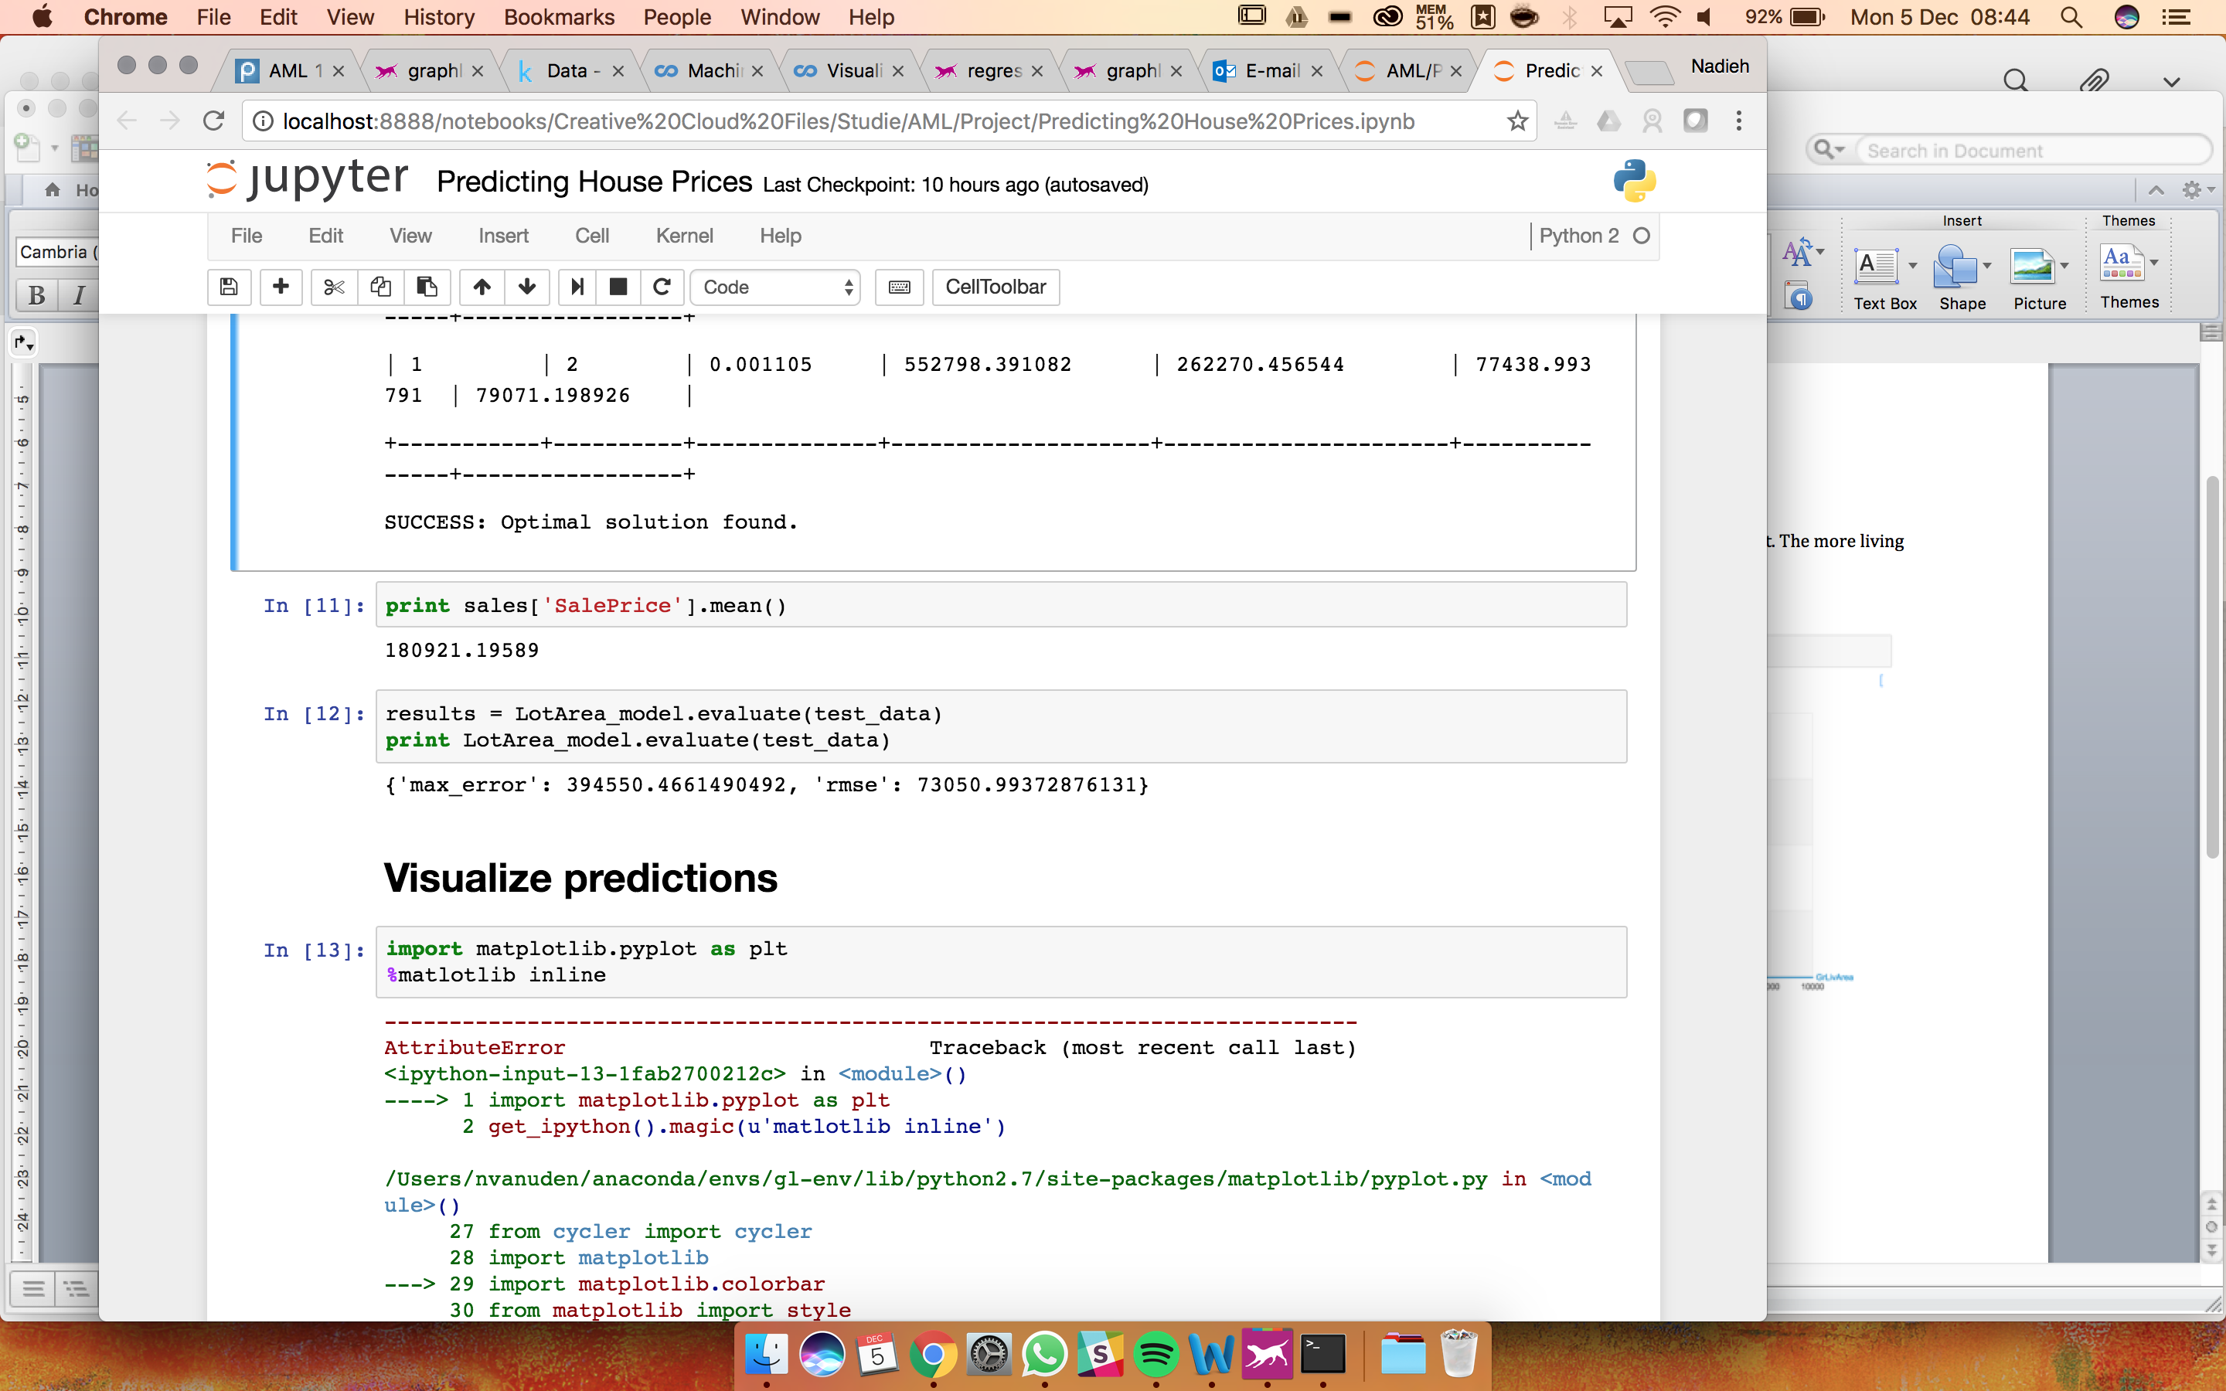

# Trying the data with other features like GrLiveArea

When using GrLivArea the graph shows more, as I would expect. The more living space, the more you pay for the house.

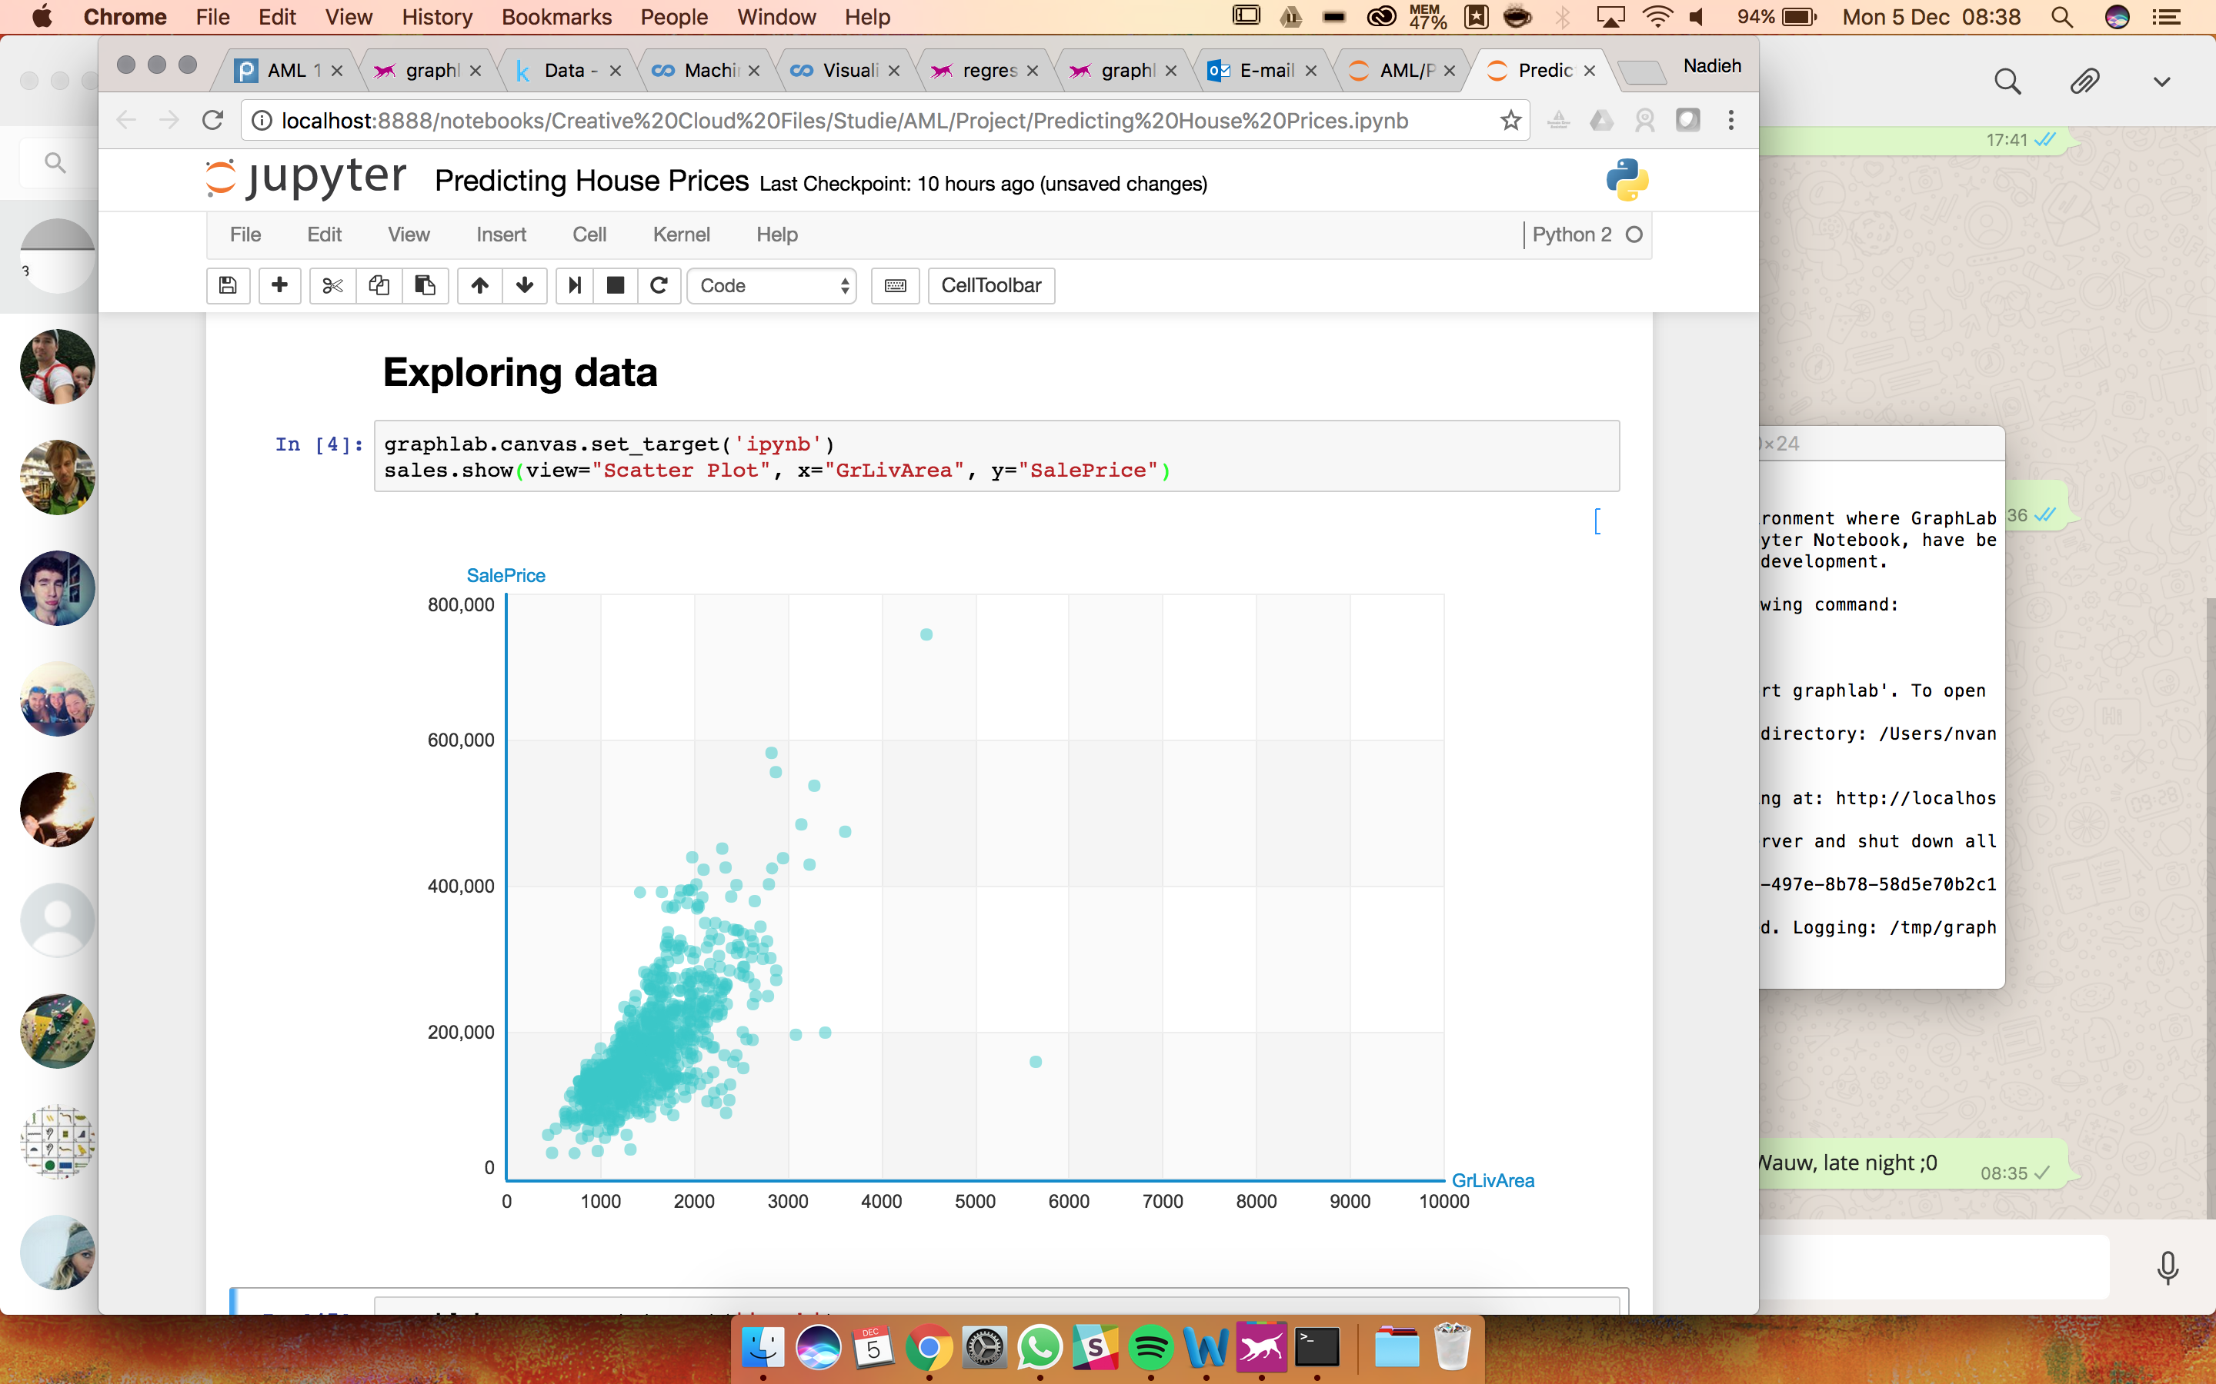

## Predict modelwith GrLivArea

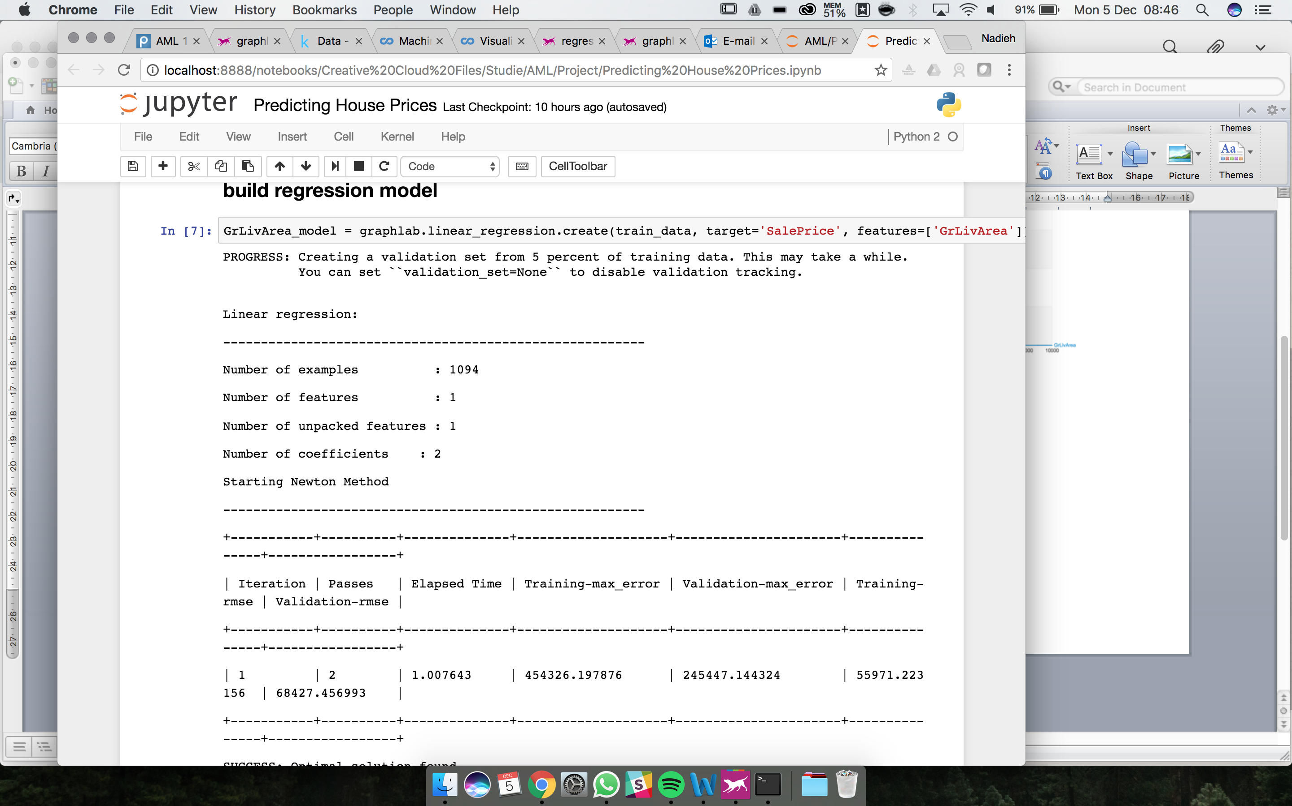

## Evaluate

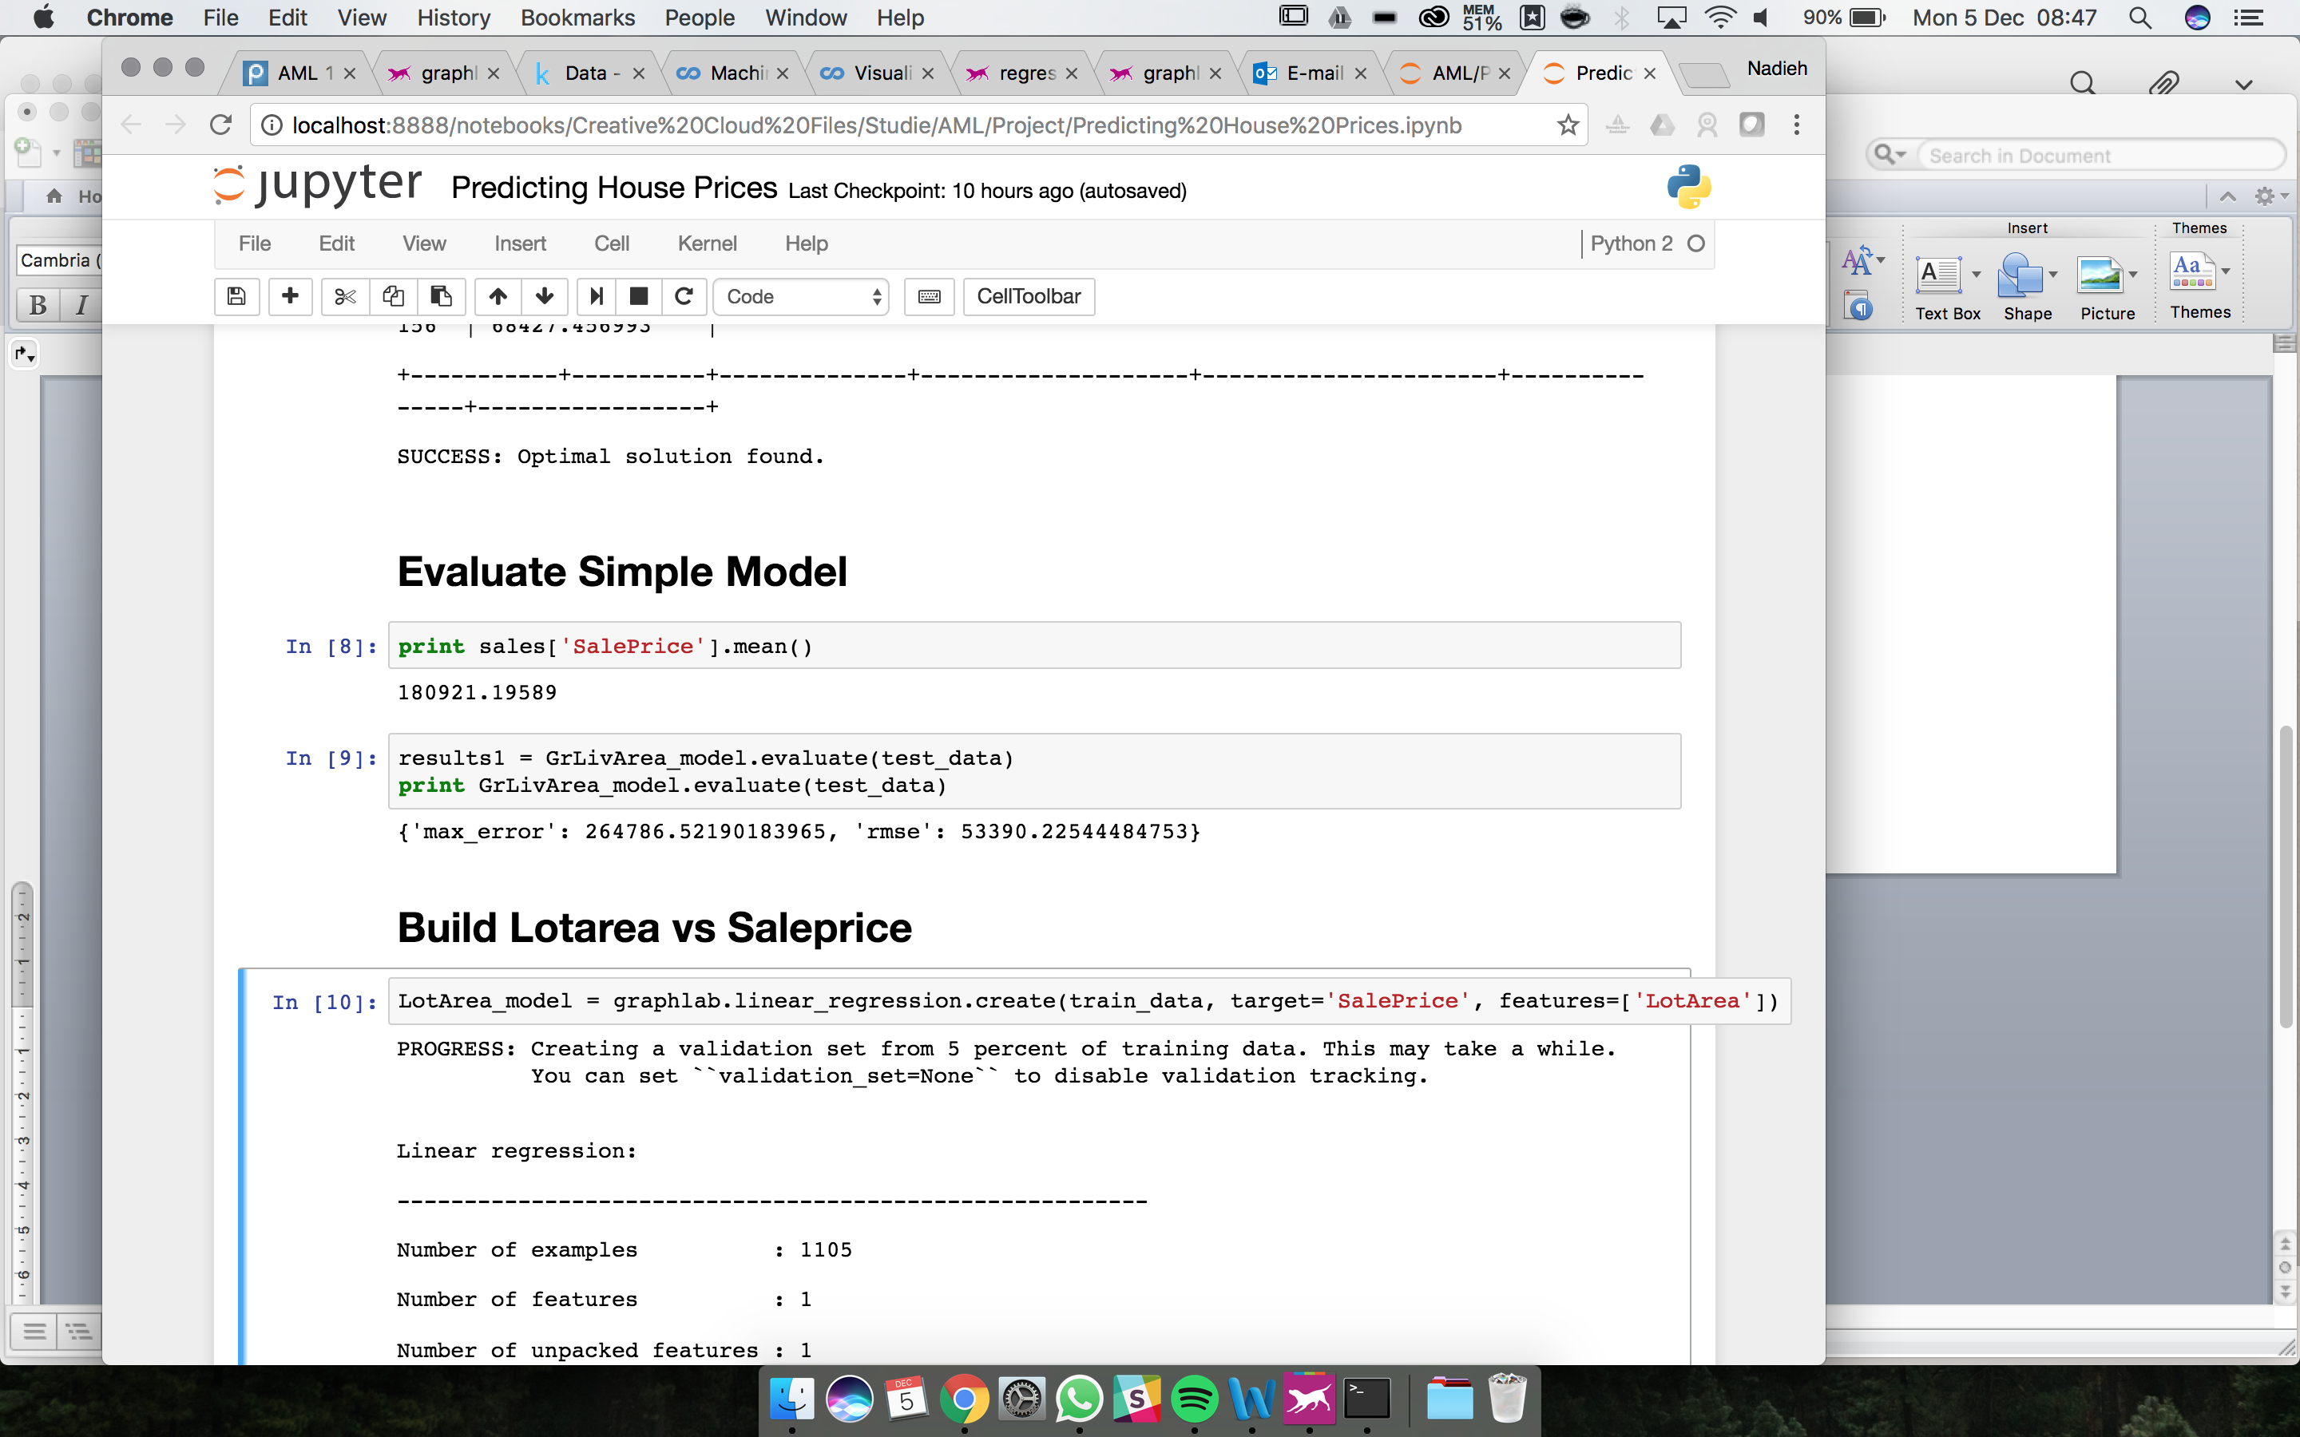

# Issues/Errors

Do you have the same error/problem with matplotlib?